**Data Dictionaries**

**Description data dictionary**

|  |  |  |  |
| --- | --- | --- | --- |
| **Entity name** | **Description** | **Aliases** | **Occurrence** |
| VirtualFridge | Store the food items of the user | Fridge | Virtual fridge page – each user has a virtual fridge |
| FoodItem | Describe details regarding an item of food | Food, product, item | In the virtual fridge, in a recipe |
| User | Store details of the person using the application | Person, chef | Throughout the application - to use the application a ‘User’ must be defined |
| Recipe | Describe and store recipes | Meal | Recipes page, profile page, virtual fridge page |
| SavedRecipe | Store recipes saved by the user |  | Profile page |
| Follow | Store the users the user is followed by and is following |  | Profile page |
| Comment | Store comments made by users regarding a recipe |  | Recipes page |

**Global ER Diagram**

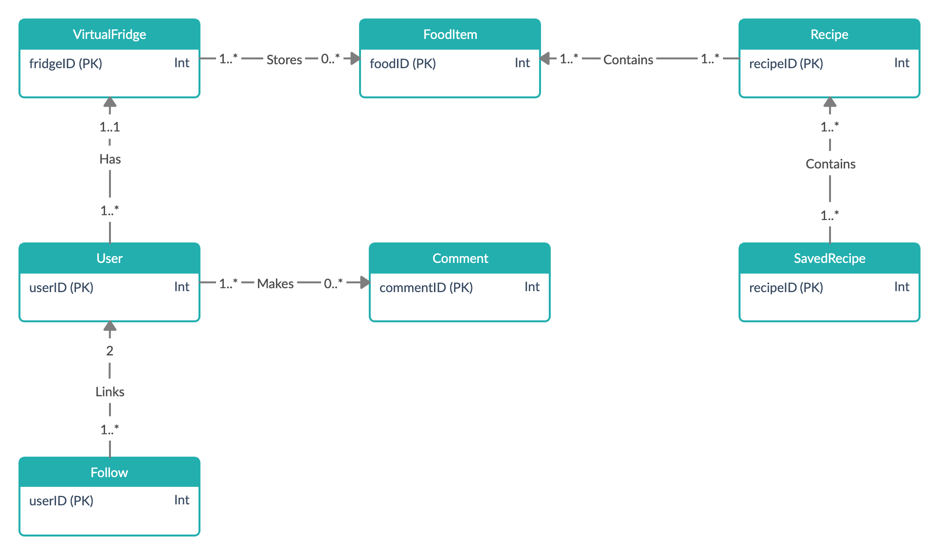

**Relationships data dictionary**

|  |  |  |  |  |
| --- | --- | --- | --- | --- |
| **Entity name** | **Multiplicity** | **Relationship** | **Multiplicity** | **Entity name** |
| VirtualFridge | 1..* | Stores | 0..* | FoodItem |
| User | 1..* | Has | 1..1 | VirtualFridge |
| User | 1..* | Makes | 0..* | Comment |
| Recipe | 1..* | Contains | 1..* | FoodItem |
| SavedRecipe | 1..* | Contains | 1..* | Recipe |
| Follow | 1..* | Links | 2 | User |

**Attributes data dictionary**

No attributes are multi-valued

|  |  |  |  |  |
| --- | --- | --- | --- | --- |
| **Entity name** | **Attributes** | **Data type and length** | **Description** | **Nulls** |
| VirtualFridge | **fridgeID (PK)**  *foodID (FK)*  quantity | int(6) fixed  int(7) fixed  int(3) variable | Uniquely identify a virtual fridge  Id of the food item in the fridge  Quantity of a food item in the fridge | No  No  No |
| FoodItem | **foodID (PK)**  name  calories  image  isVegan  isVegetarian  isPescatarian | int(7) fixed  varchar(50)  int(5) variable  varchar(50)  boolean  boolean  boolean | Uniquely identify a food item  Name of the food  Number of calories of the food  Directory of the image of the food  If the food is suitable for vegans  If the food is suitable for vegetarians  If the food is suitable for a pescatarian | No  No  Yes  Yes  No  No  No |
| User | **userID(PK)**  *fridgeID (FK)*  username  fName  lName  email  isPro  isVegan  isVegetarian  isPescatarian  followersCount  publishedRecipesCount | int(6) fixed  int(6) fixed  varchar(20)  varchar(30)  varchar(30) varchar(50)  boolean  boolean  boolean  boolean  int(6) fixed  int(6) fixed | Uniquely identify a user  ID of the user’s VirtualFridge  User’s username  User’s first name  User’s last name  User’s email  Indicate is the user is a pro user  Indicate if the user is a vegan  Indicate if the user is a vegetarian  Indicate if the user is a pescatarian  Number of followers the user has  Number of user’s published recipes | No  No  No  No  No  No  No  No  No  No  Yes  Yes |
| Recipe | **recipeID (PK)**  *userID(FK)*  name  image  ingredients  instructions  viewCount  likeCount | int(7) fixed  int(6) fixed  varchar(50)  varchar(50)  varchar(max)  varchar(max)  int(7) variable  int(7) variable | Uniquely identify a recipe  User who created the recipe  Name of the meal  Directory of the image of the food  Ingredients required to make the meal  Instructions on how to make the meal  Amount the recipe has been viewed  Number of likes the recipe has | No  No  No  Yes  No  No  No  No |
| Comment | **commentID (PK)**  *recipeID (FK)*  *userID(FK)*  commentContent | int(7) fixed  int(7) fixed  int(6) fixed  varchar(200) | Uniquely identify a comment  ID of the recipe the comment was made on  ID of user who made the comment  The actual comment that was made | No  No  No  No |
| Follow | **followerID (PK)**  **followedID (PK)** | int(6) fixed  int(6) fixed | ID of the following user  ID of the followed user | Yes  Yes |
| SavedRecipe | **recipeID (PK)**  **userID(PK)** | int(6) fixed  int(6) fixed | ID of the recipe being saved  ID of the user saving the recipe | No  No |

**Global logical data model**

|  |
| --- |
| **VirtualFridge** (fridgeID, foodID, quantity)  **Primary Key:** fridgeID  **Foreign Key:** foodID **references** FoodItem(foodID) |
| **FoodItem** (foodID,name,calories**,** image**,** isVegan**,** isVegetarian**,** isPescatarian)  **Primary Key:** foodID |
| **User** (userID, fridgeID, username,fName**,** lName**,** email**,** isPro,isVegan**,** isVegetarian**,** isPescatarian)  **Primary Key:** userID  **Foreign Key:** fridgeID **references** VirtualFridge(fridgeID) |
| **Recipe** (recipeID,userID**,** name**,** image**,** ingredients**,** instructions**,** viewCount**,** likeCount)  **Primary Key:** recipeID  **Foreign Key:** userID **references** User(userID) |
| **Comment** (commentID, recipeID, username, commentContent)  **Primary Key:** commentID  **Foreign Key:** recipeID **references** Recipe (recipeID) |
| **SavedRecipe** (recipeID, userID)  **Composite Primary Key:** recipeID, userID  **Foreign Key:** recipeID **references** Recipe (recipeID)  **Foreign Key:** username **references** User(userID) |
| **Follow** (followerID, followedID)  **Composite Primary Key:** followerID, followedID  **Foreign Key:** followerID **references** User(userID)  **Foreign Key:** followedID **references** User(userID) |

**Physical table structure**

**VirtualFridge**( fridgeID Fridge_Identification NOT NULL AUTO_INCREMENT,

foodID Food_Identification NOT NULL,

quantity Food_Quantity NOT NULL)

**Primary key:** fridgeID

**Foreign key** foodID References **FoodItem**(foodID) ON DELETE CASCADE

|  |  |
| --- | --- |
| **Domain** | **Data type and length** |
| Fridge_Identification | Fixed length integer, length 6 |
| Food_Identification | Fixed length integer, length 7 |
| Quantity | Variable length integer, max length 3 |

**FoodItem** ( foodID Food_Identification NOT NULL AUTO_INCREMENT,

name Food_Name NOT NULL,

calories Food_Calories NULL,

image Food_Image NULL

isVegan Food_Vegan NOT NULL,

isVegetarian Food_Vegetarian NOT NULL,

isPescatarian Food_Pescatarian NOT NULL)

**Primary Key:** foodID

|  |  |
| --- | --- |
| **Domain** | **Data type and length** |
| Food_Identification | Fixed length integer, length 7 |
| Food_Name | Variable length character, max length 50 |
| Food_Calories | Variable length integer, max length 5 |
| Recipe_Image | Variable length BLOB, max length |
| Food_Vegan | Boolean |
| Food_Vegetarian | Boolean |
| Food_Pescatarian | Boolean |

**User** ( userID User_Identification NOT NULL AUTO_INCREMENT,

fridgeID Fridge_Identification NOT NULL,

username Username NOT NULL,

fName First_Name NOT NULL,

lName Last_Name NOT NULL,

email Email_Address NOT NULL,

isPro User_Pro_User NOT NULL

isVegan User_Vegan NOT NULL,

isVegetarian User_Vegetarian NOT NULL,

isPescatarian User_Pescatarian NOT NULL,

followersCount Followers_Count NOT NULL,

publishedRecipesCount Recipes_Count NULL)

**Primary Key:** userID

**Foreign Key:** fridgeID **references** VirtualFridge(fridgeID) ON DELETE CASCADE

|  |  |
| --- | --- |
| **Domain** | **Data type and length** |
| User_Identification | Fixed length integer, length 6 |
| Fridge_Identification | Fixed length integer, length 6 |
| Username | Variable length character, max length 20 |
| First_Name | Variable length character, max length 30 |
| Last_Name | Variable length character, max length 30 |
| Email_Address | Variable length character, max length 50 |
| User_Pro_User | Boolean |
| User_Vegan | Boolean |
| User_Vegetarian | Boolean |
| User_Pescatarian | Boolean |
| Followers_Count | Fixed length integer, length 6 |
| Recipes_Count | Fixed length integer, length 6 |

**Recipe** (recipeID Recipe_Identification NOT NULL AUTO_INCREMENT,

userID User_Identification NOT NULL,

nameRecipe_Name NOT NULL,

image Recipe_Image NULL,

ingredients Recipe_Ingredients NOT NULL,

instructions Recipe_Instructions NOT NULL,

viewCount Recipe_Views NOT NULL,

likeCount Recipe_Likes NOT NULL)

**Primary Key:** recipeID

**Foreign Key:** userID **references** User(userID) ON DELETE CASCADE

|  |  |
| --- | --- |
| **Domain** | **Data type and length** |
| Recipe_Identification | Fixed length integer, length 6 |
| User_Identification | Fixed length integer, length 6 |
| Recipe_Name | Variable length character, max length 50 |
| Recipe_Image | Variable length character, max length 50 |
| Recipe_Ingredients | Variable length character, max length |
| Recipe_Instructions | Variable length character, max length |
| Recipe_Views | Variable length integer, max length 6 |
| Recipe_Likes | Variable length integer, max length 6 |

**Comment** (commentID Comment_Identification NOT NULL AUTO_INCREMENT,

recipeID Recipe_Identification NOT NULL,

userID User_Identification NOT NULL,

commentContent Comment’s_Content NOT NULL,)

**Primary Key:** commentID

**Foreign Key:** recipeID **references** Recipe (recipeID) ON DELETE CASCADE

**Foreign Key:** userID **references** User (userID) ON DELETE CASCADE

|  |  |
| --- | --- |
| **Domain** | **Data type and length** |
| Comment_Identification | Fixed length integer, length 7 |
| Recipe_Identification | Fixed length integer, length 7 |
| User_Identification | Fixed length integer, length 6 |
| Comment’s_Content | Variable length character, max length 200 |

**SavedRecipe** (recipeID Recipe_Identification NOT NULL,

userID User_Identification NOT NULL)

**Composite Primary Key:** recipeID, userID

**Foreign Key:** recipeID **references** Recipe (recipeID)

**Foreign Key:** userID **references** User(userID) ON DELETE CASCADE

|  |  |
| --- | --- |
| **Domain** | **Data type and length** |
| Recipe_Identification | Fixed length integer, length 7 |
| User_Identification | Fixed length integer, length 6 |

**Follow** (followerID Following_User_Identification NOT NULL,

followedID Followed_User__Identification NOT NULL)

**Composite Primary Key:** followerID, followedID

**Foreign Key:** followerID **references** User(userID) ON DELETE CASCADE

**Foreign Key:** followingID **references** User(userID) ON DELETE CASCADE

|  |  |
| --- | --- |
| **Domain** | **Data type and length** |
| Following_User_Identification | Fixed length integer, length 6 |
| Followed_User__Identification | Fixed length integer, length 6 |

**Business rules**

**User**

* The password must be greater than 6 characters, contain an uppercase character a, number and a special character – this will be validated using a regex pattern in the implementation stage
* The first and last names must be a sequence of letters only - this will be validated using a regex pattern in the implementation stage
* The email address must be in the format of a valid email address – this will be validated by making the text field input type an email address in Android Studio which will ensure that the input is a valid email address format

**Virtual Fridge**

* User should be unable to input a quantity <=0 for a food item in the virtual fridge – use a suitable condition to validate input in implementation
* User should be unable to input a quantity greater than 999 for a food item in the virtual fridge - use a suitable condition to validate input in implementation